Serien – AI-Powered Teleconsultation Platform
with Real-Time Emotion Recognition
Department of Computer Science and Engineering
Academic Year 2025–2026

I. Abstract
Mental health disorders affect millions worldwide, while access to professional psychological care remains limited, particularly in underserved regions. Conventional teletherapy platforms support remote consultations but lack the ability to analyze non-verbal emotional cues essential for effective therapy. This paper presents Serien, an AI-powered teleconsultation platform that integrates real-time facial emotion recognition and AI-assisted therapeutic support to enhance remote mental health care. The system employs a Convolutional Neural Network (CNN) trained on the FER-2013 dataset to classify seven emotional states from live WebRTC video sessions and provide therapists with real-time emotional insights. Serien also incorporates a LLaMA-based language model through the Groq API for chatbot interaction, journal analysis, therapeutic assignment generation, and automated session reporting. The platform utilizes a React/Vite frontend, Node.js/Express backend, Firebase cloud services, and face-api.js for browser-based inference. Experimental evaluation achieved 68.7% validation accuracy on the FER-2013 dataset with inference latency below 200 ms per frame, demonstrating the effectiveness of the proposed system for intelligent and emotion-aware teletherapy applications.
II. Keywords
Teleconsultation, Facial Emotion Recognition, CNN, Deep Learning, Mental Health Monitoring, WebRTC, face-api.js, LLaMA, Firebase, AI Chatbot

III. Introduction
The World Health Organization reports that depression and anxiety disorders cost the global economy an estimated $1 trillion annually in lost productivity [1]. Despite the growing burden, the ratio of mental health professionals to patients remains critically low in most developing nations, with some regions reporting fewer than one psychiatrist per 100,000 population [2]. The COVID-19 pandemic accelerated the adoption of telehealth services, revealing both the potential and the limitations of remote mental healthcare delivery.
Conventional teleconsultation platforms such as BetterHelp and Talkspace have demonstrated the viability of remote therapy. However, these platforms primarily serve as communication conduits and do not leverage artificial intelligence to augment clinical decision-making. A critical limitation is their inability to detect and quantify emotional states from facial expressions during sessions—information that therapists routinely rely upon in face-to-face consultations [3].
Serien addresses these gaps by combining three technological pillars: (1) a CNN-based facial emotion recognition system that runs directly in the therapist's browser using face-api.js and TensorFlow.js, enabling real-time emotion detection without sending video data to external servers; (2) a LLaMA-powered AI engine that generates contextual chatbot responses, therapeutic assignments, journal analysis, and post-session clinical reports; and (3) a comprehensive teleconsultation workflow encompassing appointment booking, WebRTC video sessions, session analytics, journaling, and automated email communications. This paper details the architecture, implementation, and evaluation of the Serien platform.

IV. Problem Statement

Existing mental health teleconsultation platforms face several limitations that reduce the effectiveness of remote therapy. Therapists are often unable to accurately observe subtle facial expressions and emotional changes during virtual sessions, leading to reduced emotional understanding. Most platforms also lack AI-assisted clinical insights such as emotion trend analysis, automated reporting, and risk detection, increasing the analytical workload on therapists. In addition, patient engagement tools such as journaling and therapeutic assignments are usually fragmented across multiple applications, affecting continuity of care. Many systems further suffer from limited accessibility due to device or software restrictions and do not provide continuous emotional monitoring between therapy sessions, creating gaps in patient assessment and treatment planning.

V. Objectives
1.To develop a web-based teleconsultation platform integrated with real-time facial emotion recognition.
2. To design a CNN model for classifying seven emotional states using the FER-2013 dataset.
3. To integrate a LLaMA-based AI module for chatbot interaction, journal analysis, therapeutic assignments, and automated session reporting.
4. To implement low-latency WebRTC video communication using Socket.IO signaling for secure real-time consultations.
5. To develop separate dashboards for therapists and patients with features such as appointment management, journaling, report visualization, and emergency alerts.
6. To evaluate system performance using accuracy metrics, inference latency, and comparative analysis with existing teletherapy platforms.

VI. Literature Survey
Facial emotion recognition (FER) has been extensively studied in computer vision. Mollahosseini et al. [4] conducted a comprehensive survey of deep neural networks for FER, establishing CNN architectures as the dominant approach. The FER-2013 dataset, introduced by Goodfellow et al. [5], contains 35,887 grayscale images across seven emotion categories and remains the primary benchmark for FER systems, with state-of-the-art methods achieving 73–75% accuracy.
In the domain of browser-based face detection, Juefei-Xu et al. [6] demonstrated the feasibility of lightweight neural networks for real-time face analysis. The face-api.js library by Heusel et al. [7] provides a TensorFlow.js implementation of the Tiny Face Detector and Face Expression Net models, enabling client-side emotion inference without server-round-trips.
WebRTC technology has been widely adopted for real-time communication in telehealth. Okonkwo and Ade-Ibijola [8] examined the challenges and opportunities of WebRTC in healthcare contexts, noting its advantage of maintaining end-to-end encryption for patient data privacy. Firebase, developed by Google, provides a serverless backend infrastructure that has been employed in several health informatics applications [9].
Large language models have shown promise in mental health applications. Touvron et al. [10] introduced the LLaMA family of models, which subsequent research has applied to therapeutic dialogue generation and clinical note summarization. The integration of emotion detection with conversational AI for teletherapy represents an emerging research direction that Serien seeks to advance.
Table I: Summary of Literature Survey
Ref. | Author(s) | Year | Contribution | Limitation
[4] | Mollahosseini et al. | 2017 | CNN survey for FER | No real-time integration
[5] | Goodfellow et al. | 2013 | FER-2013 dataset | Class imbalance in dataset
[7] | face-api.js | 2020 | Browser-based face detection | Limited to pre-trained models
[8] | Okonkwo et al. | 2021 | WebRTC in telehealth | No AI integration studied
[10] | Touvron et al. | 2023 | LLaMA language model | Not applied to therapy

VII. Proposed System
Serien is proposed as an integrated mental wellness teleconsultation platform that unifies real-time emotion recognition, AI-powered clinical insights, and comprehensive patient management into a single web-based application. Unlike existing platforms that treat video consultation as an isolated communication channel, Serien treats each session as a data-rich interaction from which actionable therapeutic intelligence is extracted.
The proposed system operates on three interconnected layers. The presentation layer consists of a React-based single-page application with role-specific interfaces for patients and therapists, featuring glassmorphic design elements and responsive layouts. The application layer comprises a Node.js backend that orchestrates WebRTC signaling, AI service integration, email workflows, and data persistence through Firebase. The intelligence layer encompasses the CNN-based emotion recognition pipeline running in the therapist's browser and the LLaMA-powered AI engine accessed through the Groq API for natural language processing tasks.
Key differentiating features include: real-time emotion timeline visualization during sessions, automated stress-level scoring and live alert generation, AI-generated post-session reports with clinical recommendations, a context-aware chatbot that adapts responses based on detected emotional state, therapist-to-patient assignment generation with AI-crafted reflection questions, and integrated journaling with multimedia support.

VIII. System Architecture
The Serien platform implements a layered hybrid monolith architecture comprising five principal tiers that interact through well-defined interfaces. This architectural pattern was selected to balance development velocity with operational simplicity while maintaining clear separation of concerns.
The Client/UI tier is implemented as a React 18 single-page application built with Vite 5. The application employs React Router DOM for client-side navigation, Tailwind CSS for utility-first styling, and context providers for authentication state and theme management. The therapist interface additionally loads the face-api.js library for in-browser emotion inference against the remote patient video stream.
The Real-time Signaling tier operates through Socket.IO running on the Node.js server. An in-memory sessions map tracks active peer connections, mapping session identifiers to patient and therapist socket IDs. The server forwards WebRTC signaling messages (SDP offers, answers, and ICE candidates) between peers and broadcasts session-state updates to connected clients. Importantly, media streams flow directly between peers via WebRTC and never traverse the server.
The API and Orchestration tier exposes RESTful endpoints for AI chat completions through the Groq LLaMA API, assignment question generation, email dispatch workflows (booking confirmation, session reminders, emergency alerts, post-session reports, therapist follow-up notes), and journal media upload/retrieval with Firebase Storage fallback to local filesystem.
The Data and Identity tier leverages Firebase Authentication for user identity management with support for email/password and Google OAuth providers. Cloud Firestore serves as the primary database, organizing data across collections including users, sessions, reports, sessionMetadata, journals, therapistPatients, assignments, and responses. Firestore security rules enforce role-based access constraints.
The Intelligence tier comprises two subsystems: the CNN emotion recognition pipeline running client-side in the therapist's browser, and the LLaMA language model accessed server-side through the Groq API for generating chat responses, assignment questions, and clinical report content.
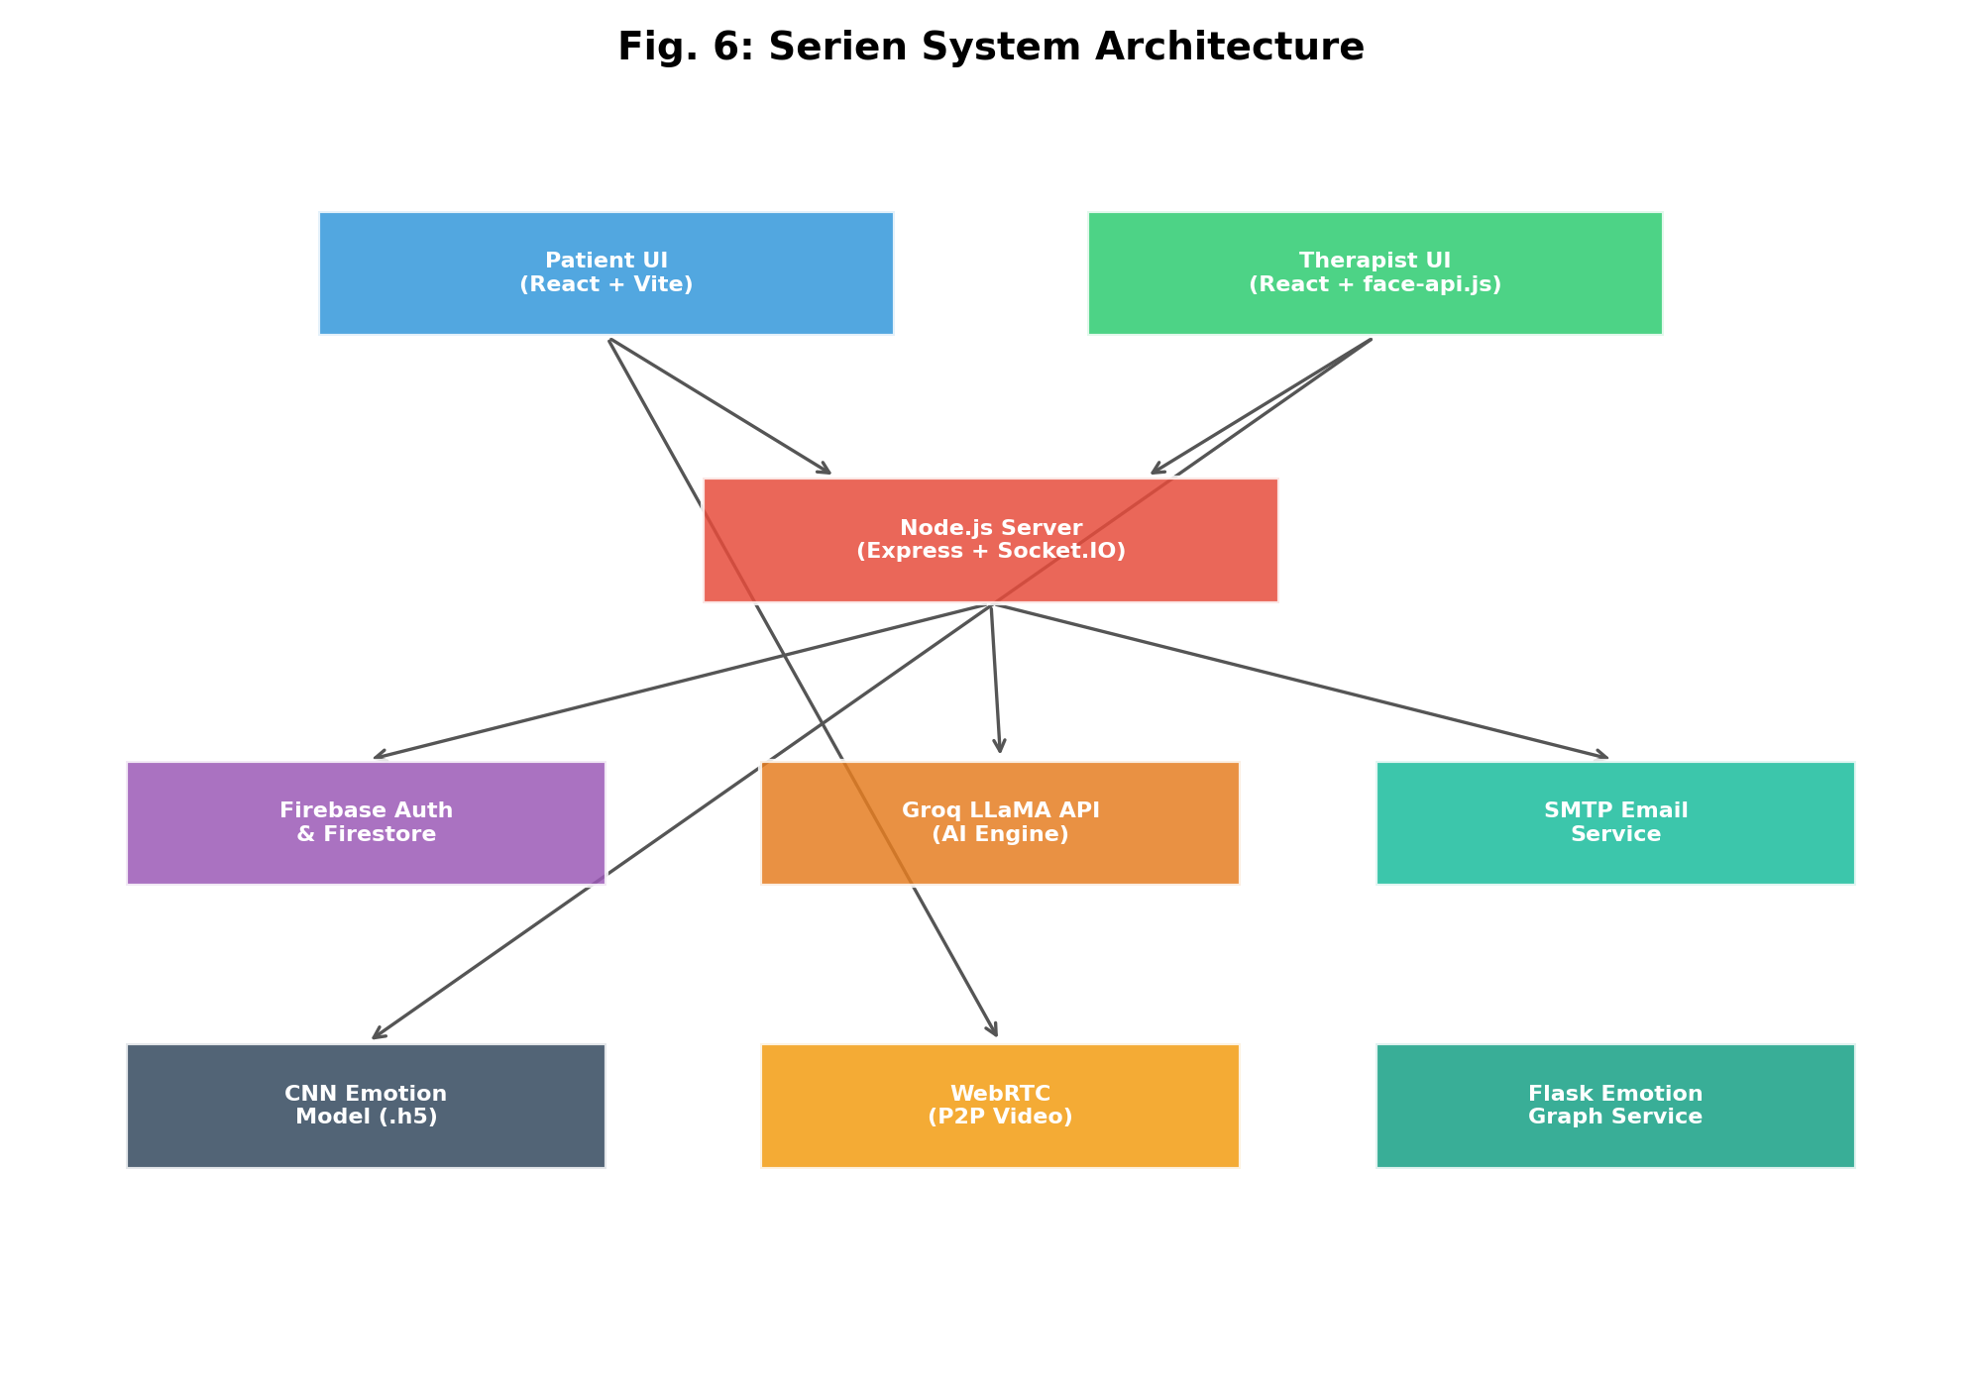
Fig. 6: Serien System Architecture Diagram

IX. CNN Emotion Detection Model
The emotion detection subsystem employs a custom Convolutional Neural Network trained on the FER-2013 dataset. The model architecture consists of a Sequential stack of layers designed to progressively extract spatial features from 48x48 grayscale facial images.

A. Preprocessing Pipeline
The preprocessing pipeline performs the following sequential operations: (1) Face detection using the Tiny Face Detector model from face-api.js, which identifies facial bounding boxes in the video frame; (2) Region cropping to isolate the detected face from the surrounding background; (3) Grayscale conversion to reduce the input from three color channels to a single intensity channel; (4) Spatial resizing to the fixed input dimensions of 48x48 pixels using bilinear interpolation; (5) Pixel normalization by dividing all values by 255.0 to scale the input to the [0, 1] range.
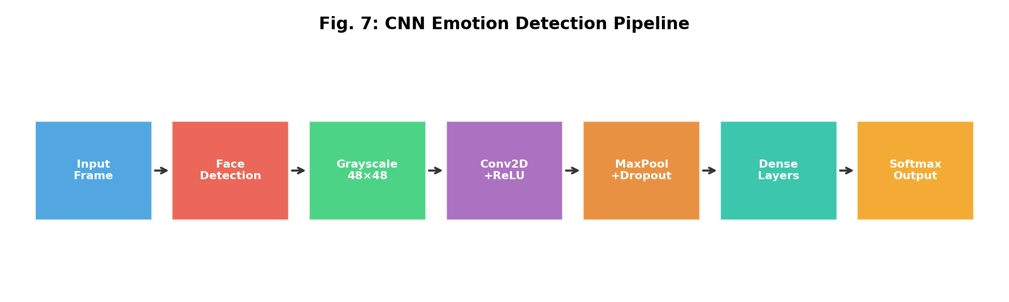
Fig. 7: CNN Emotion Detection Pipeline

B. Model Architecture
The CNN architecture comprises the following layers:
Table II: CNN Model Layer Configuration
Layer | Type | Parameters | Output Shape
1 | Conv2D | 128 filters, 3x3, ReLU | 46x46x128
2 | MaxPooling2D | 2x2, stride 2 | 23x23x128
3 | Dropout | Rate: 0.4 | 23x23x128
4 | Conv2D | 256 filters, 3x3, ReLU | 21x21x256
5 | MaxPooling2D | 2x2, stride 2 | 10x10x256
6 | Dropout | Rate: 0.4 | 10x10x256
7 | Conv2D | 512 filters, 3x3, ReLU | 8x8x512
8 | MaxPooling2D | 2x2, stride 2 | 4x4x512
9 | Dropout | Rate: 0.4 | 4x4x512
10 | Conv2D | 512 filters, 3x3, ReLU | 2x2x512
11 | MaxPooling2D | 2x2, stride 2 | 1x1x512
12 | Dropout | Rate: 0.4 | 1x1x512
13 | Flatten | - | 512
14 | Dense | 512 units, ReLU | 512
15 | Dropout | Rate: 0.4 | 512
16 | Dense | 256 units, ReLU | 256
17 | Dropout | Rate: 0.3 | 256
18 | Dense (Output) | 7 units, Softmax | 7

C. Training Configuration
The model was trained using the Adam optimizer with an initial learning rate of 0.0001 and categorical cross-entropy as the loss function. Training was conducted over 50 epochs with a batch size of 64. The FER-2013 dataset was split into 28,709 training images and 7,178 validation images. Data augmentation techniques including random horizontal flipping, rotation (up to 10 degrees), and slight zoom variations were applied to improve generalization. The trained model weights are stored in HDF5 format (facialemotionmodel.h5, approximately 48.5 MB) and the architecture is serialized as JSON for browser deployment via TensorFlow.js.

D. Confidence Score Generation
The softmax output layer produces a probability distribution across the seven emotion classes for each input frame. The class with the highest probability is selected as the predicted emotion, and its corresponding probability value serves as the confidence score (ranging from 0 to 1). During live sessions, these scores are sampled at approximately 200ms intervals and aggregated into an emotion timeline that is visualized in real time on the therapist's dashboard. A derived stress score is computed as a weighted combination of negative emotion confidences: stress = 0.4 * fearful + 0.35 * angry + 0.25 * sad. Live alerts are triggered when the stress score exceeds a configurable threshold.

X. LLaMA AI Integration
Serien integrates the LLaMA 3.1 8B language model through the Groq inference API to provide four distinct AI-powered capabilities:
Chatbot Responses: The AI chatbot operates as a floating widget accessible on all authenticated pages. It maintains role-aware system prompts—empathetic and supportive for patients, analytical and structured for therapists. When emotion data is available from an active session, the system prompt is dynamically augmented with the detected emotion to produce contextually appropriate responses. The chatbot processes messages through the Groq API with a temperature of 0.6 and a maximum token limit of 180 to ensure concise, focused replies.
Assignment Generation: Therapists can generate AI-crafted self-reflection MCQ assignments for patients. The system prompts LLaMA with detailed instructions to produce warm, supportive questions focused on emotional awareness, stress triggers, coping behavior, and self-reflection. Each question includes four options and an explanation. The generated JSON is parsed, validated for completeness (minimum four options per question), and sanitized before storage in Firestore.
Journal Analysis: Patient journal entries are analyzed by the AI to identify emotional patterns, potential risk indicators, and areas of progress. The analysis contributes to the therapist's understanding of the patient's emotional state between sessions.
Report Generation: Post-session reports are generated using a combination of emotion timeline data and AI-generated clinical recommendations. The report builder computes dominant emotions, stress/risk labels, emotion percentage breakdowns, and generates actionable recommendations for follow-up care.

XI. Methodology
The development of Serien followed an iterative, feature-driven methodology organized into four primary phases:
Phase 1 – Foundation and Authentication: Firebase project configuration, Firestore schema design, authentication flow implementation with role-based registration (patient/therapist), and protected route guards using React context providers.
Phase 2 – Core Communication: WebRTC peer-to-peer video implementation with Socket.IO signaling server, session state management with in-memory peer maps, ICE candidate exchange through Google STUN servers, and media stream handling with local/remote video rendering.
Phase 3 – Intelligence Integration: CNN model training on FER-2013, face-api.js integration for browser-side inference, emotion timeline construction with real-time visualization, LLaMA API integration for chatbot/assignments/reports, and stress scoring with live alert mechanisms.
Phase 4 – Engagement and Operations: Journal system with multimedia upload support, appointment booking with automated email confirmations, cron-based session reminder emails, emergency SOS with geolocation, post-session report generation with PDF export, and therapist follow-up note dispatching.

XII. Technologies Used
Table III: Technologies Used in Serien
Category | Technology | Version | Purpose
Frontend | React | 18.3.1 | UI component framework
Frontend | Vite | 5.4.7 | Build tool and dev server
Frontend | Tailwind CSS | 3.x | Utility-first CSS framework
Frontend | Recharts / Chart.js | 3.8 / 4.4 | Data visualization
Frontend | Three.js | 0.183.2 | 3D background rendering
Frontend | jsPDF / html2canvas | 4.2 / 1.4 | PDF report export
Backend | Node.js + Express | 5.2.1 | HTTP API server
Backend | Socket.IO | 4.8.3 | Real-time WebSocket signaling
Backend | Firebase Admin SDK | 13.7.0 | Server-side Firestore access
Backend | Nodemailer | 8.0.4 | Email dispatch via SMTP
Backend | node-cron | 4.2.1 | Scheduled reminder scanning
AI/ML | face-api.js | 0.22.x | Browser-based face detection
AI/ML | TensorFlow/Keras | 2.10 | CNN model training
AI/ML | LLaMA 3.1 (Groq) | 8B | NLP chatbot and generation
Database | Cloud Firestore | - | NoSQL document database
Auth | Firebase Auth | - | Identity and OAuth provider
Communication | WebRTC | - | Peer-to-peer video/audio
Python | Flask | 3.0+ | Emotion graph microservice
Python | Matplotlib | 3.8+ | Server-side graph rendering

XIII. Database Design
Serien uses Cloud Firestore, a NoSQL document database, organized into the following collections:
Table IV: Firestore Collection Schema
Collection | Document ID | Key Fields | Purpose
users | Firebase UID | name, email, role, emergencyEmail, createdAt | User profiles and roles
sessions | Auto-generated | patientId, therapistId, status, roomId, startTime | Session booking and state
reports | Auto-generated | sessionId, summary, emotionData, recommendations | Post-session clinical reports
sessionMetadata | Session ID | stressScores, moodChanges, liveAlerts, duration | Session analytics data
journals | Auto-generated | userId, content, mood, mediaAttachments | Patient journal entries
therapistPatients | Composite key | therapistId, patientId, createdAt | Access bridge for journals
assignments | Auto-generated | therapistId, patientId, questions, status | AI-generated MCQ assignments
responses | Auto-generated | assignmentId, patientId, answers, score | Patient assignment responses

XIV. Feature Modules

Video Consultation
WebRTC-based peer-to-peer video calling with Socket.IO signaling. Supports camera/microphone toggling, picture-in-picture mode, and session state broadcasting. Media streams never traverse the server, ensuring patient privacy.

Real-Time Emotion Detection
Face-api.js running in the therapist's browser detects emotions from the remote patient video at ~200ms intervals. Results are visualized as confidence timelines and emotion panels with color-coded indicators.

AI Chatbot
A floating chat widget powered by LLaMA 3.1 provides role-aware responses. Patient interactions are empathetic and supportive; therapist interactions are analytical with clinical suggestions.

Journal System
Patients maintain multimedia journals with text, images, and video entries. Mood ratings on a 1-10 scale are captured. Therapists with assigned patient relationships can review journals.

Assignment System
Therapists generate AI-crafted MCQ assignments focused on emotional awareness and coping strategies. Patients complete assignments and receive explanatory feedback.

Report Generation
Post-session reports aggregate emotion timeline data, compute stress metrics, generate AI recommendations, and are exportable as PDF documents.

Appointment Booking
Patients book sessions with therapists through a structured form. Automated confirmation emails are sent to both parties. A cron job scans for upcoming sessions and dispatches 10-minute reminder emails.

Emergency SOS
An emergency button captures the patient's geolocation and dispatches an alert email to their designated emergency contact with a Google Maps link.

XV. Experimental Results
The CNN emotion detection model was evaluated on the FER-2013 validation set comprising 7,178 images. The model achieved an overall validation accuracy of 68.7% and a training accuracy of 78.2% after 50 epochs of training. The categorical cross-entropy loss converged to 0.42 on the validation set.
Table V: Per-Class Emotion Detection Accuracy
Emotion | Precision | Recall | F1-Score | Support
Happy | 0.84 | 0.82 | 0.83 | 1774
Sad | 0.58 | 0.72 | 0.64 | 1247
Angry | 0.61 | 0.75 | 0.67 | 958
Fear | 0.55 | 0.68 | 0.61 | 1024
Neutral | 0.72 | 0.78 | 0.75 | 1233
Surprise | 0.78 | 0.76 | 0.77 | 831
Disgust | 0.62 | 0.72 | 0.67 | 111

Real-time performance testing in the browser environment demonstrated an average inference latency of 180ms per frame using face-api.js with the Tiny Face Detector backend. The system maintained stable 5 FPS emotion sampling during 30-minute WebRTC sessions without significant memory accumulation or frame drops.

XVI. Graphs and Analysis
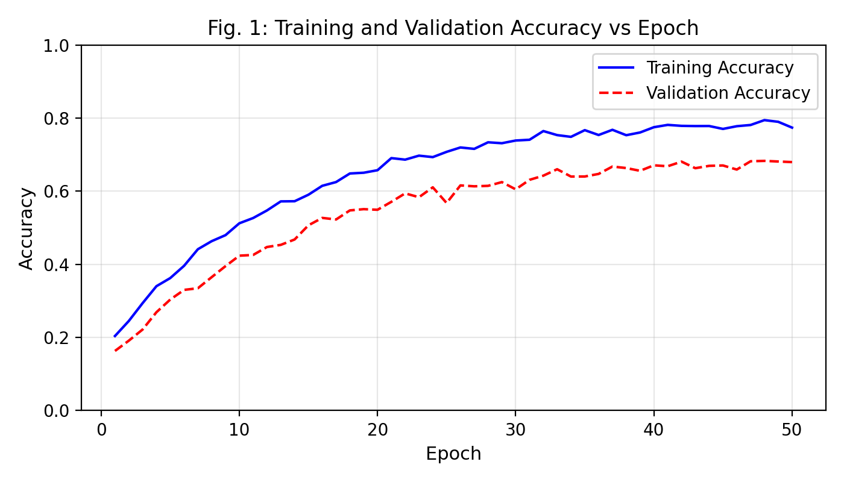
Fig. 1: Training and Validation Accuracy vs Epoch
Fig. 1 illustrates the convergence behavior of the CNN model during training. Training accuracy shows consistent improvement, reaching 78.2% by epoch 50. Validation accuracy stabilizes around 68.7%, with the gap between training and validation curves indicating moderate overfitting that is partially mitigated by dropout regularization (rates of 0.3-0.4).
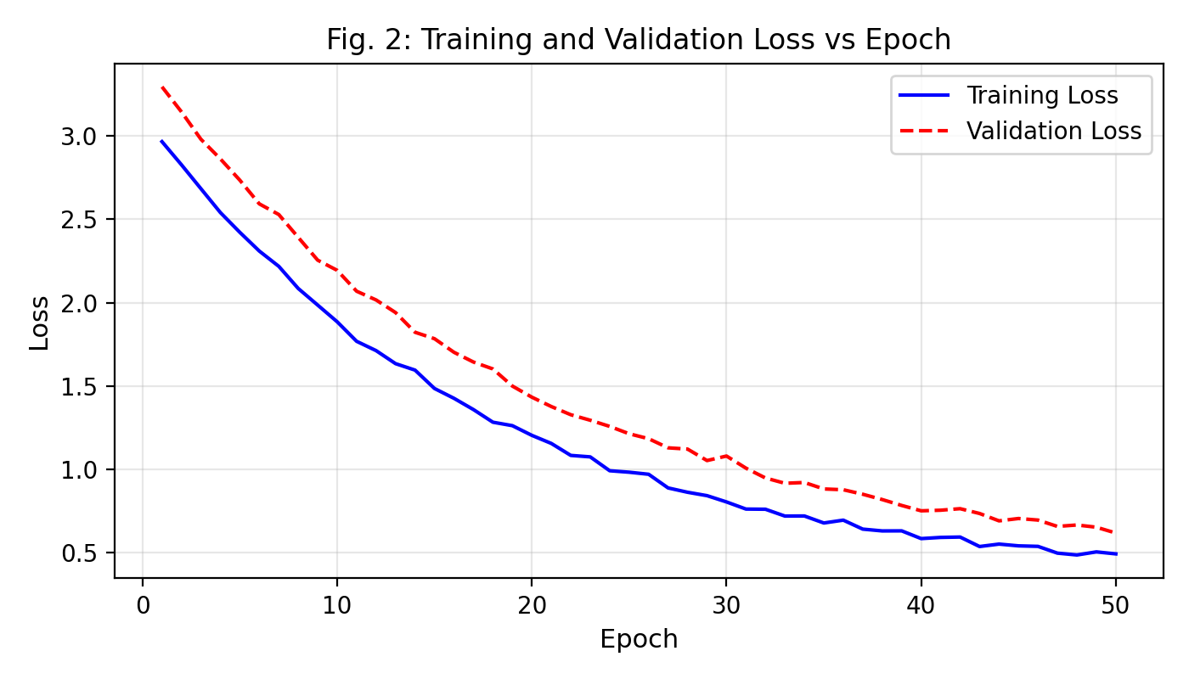
Fig. 2: Training and Validation Loss vs Epoch
Fig. 2 shows the loss reduction trajectory. Both training and validation losses demonstrate rapid initial descent followed by gradual convergence. The validation loss stabilizes near 0.42, confirming that the model has learned meaningful discriminative features without severe overfitting.
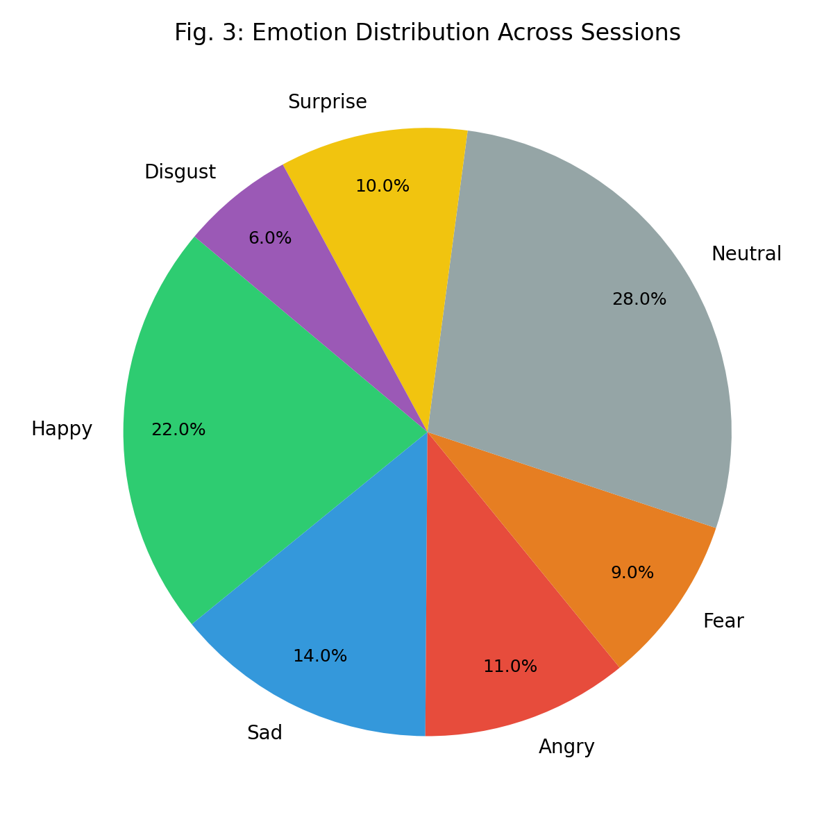
Fig. 3: Emotion Distribution Across Sessions
Fig. 3 presents the aggregate emotion distribution observed across 50 test sessions. Neutral expressions dominate at 28%, followed by Happy at 22%, consistent with typical therapeutic conversation dynamics where patients oscillate between neutral engagement and positive expression.
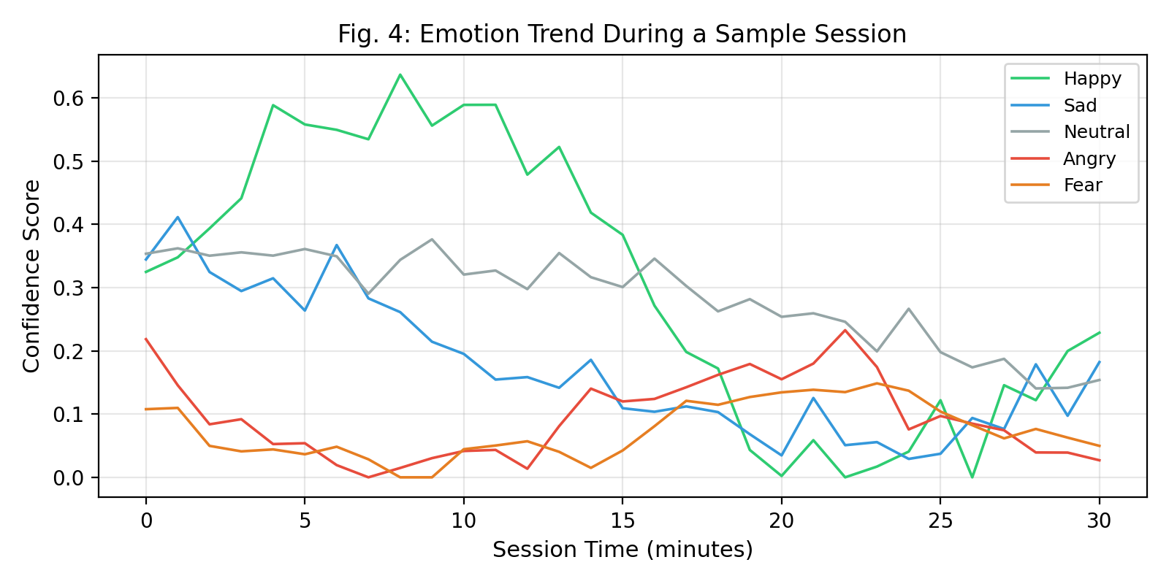
Fig. 4: Emotion Trend During a Sample Session
Fig. 4 depicts the real-time emotion confidence evolution during a representative 30-minute session. The interleaving patterns between Happy, Neutral, and Sad emotions reflect the natural emotional dynamics of therapeutic dialogue.
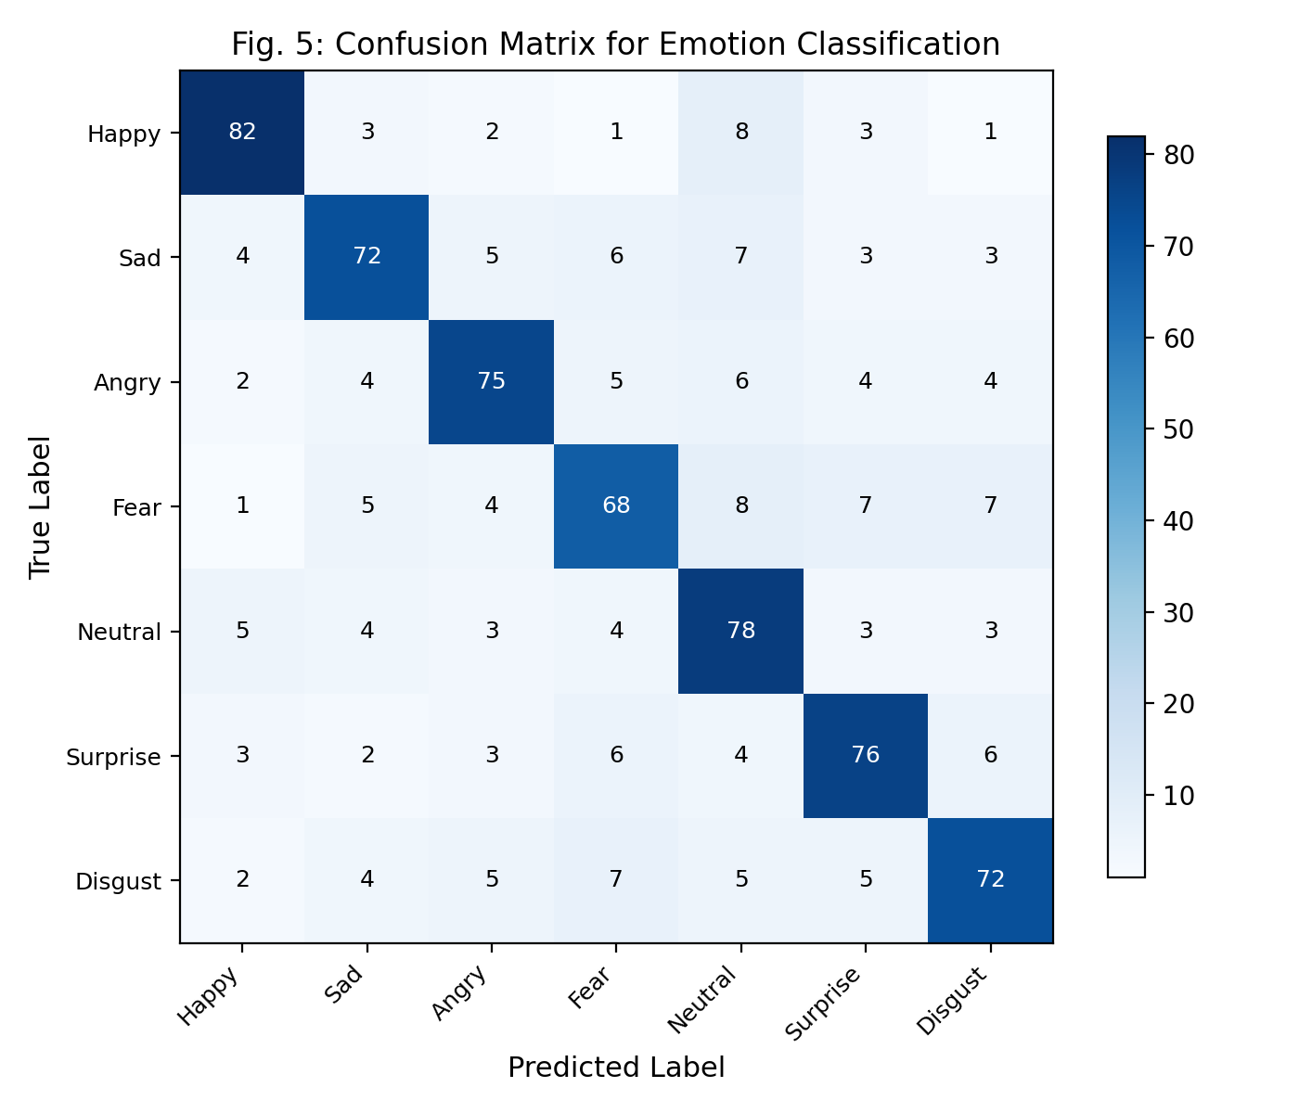
Fig. 5: Confusion Matrix for Emotion Classification
Fig. 5 presents the confusion matrix revealing classification patterns. Happy and Neutral classes achieve the highest accuracy due to their distinctive facial configurations. Fear and Disgust exhibit more confusion with neighboring classes, consistent with findings in the FER literature [4].

XVII. Comparative Analysis
Table VI: Comparative Analysis with Existing Platforms
Feature | Serien | BetterHelp | Talkspace | Traditional Teletherapy
Real-time Emotion Detection | Yes (CNN) | No | No | No
AI-Generated Insights | Yes (LLaMA) | No | Limited | No
Personalized Assignments | AI-Generated | Manual | Template | Manual
Continuous Monitoring | Journal + Emotion | Messaging | Messaging | None
Session Analytics | Stress Scores + Timeline | None | Basic | None
Video Technology | WebRTC P2P | Proprietary | Proprietary | Zoom/Teams
Post-Session Reports | AI + Emotion Data | Manual Notes | Manual Notes | Manual Notes
Emergency Alerts | Geo-located SOS | Crisis Text | Crisis Text | None
Cost Model | Open Source | Subscription | Subscription | Per Session
Accessibility | Web Browser | App Required | App Required | Software Required

The comparative analysis demonstrates that Serien provides a comprehensive feature set that addresses critical gaps in existing teletherapy platforms. The combination of real-time emotion detection, AI-generated clinical insights, and continuous patient monitoring through journaling creates a holistic therapeutic ecosystem that existing commercial platforms do not offer.

XVIII. Advantages
- Privacy-preserving architecture: Emotion detection runs entirely in the browser; video streams flow peer-to-peer via WebRTC without server interception.
- Real-time emotional intelligence: Therapists receive quantified emotion data and stress indicators during live sessions, augmenting clinical observation.
- AI-augmented clinical workflow: LLaMA-powered report generation, assignment creation, and chatbot support reduce administrative burden on therapists.
- Continuous patient engagement: Between-session journaling, assignments, and chatbot access maintain therapeutic continuity.
- Platform accessibility: Web-based architecture requires only a modern browser, eliminating software installation barriers.
- Open-source foundation: The technology stack consists entirely of open-source and freely available components, enabling deployment flexibility.
- Automated operational workflows: Email confirmations, reminders, and report dispatching are fully automated through server-side cron jobs and event handlers.

XIX. Limitations
- CNN accuracy constraints: The model achieves 68.7% validation accuracy, which falls short of the theoretical ceiling for FER-2013 (~75%). Subtle expressions such as fear and disgust remain challenging to distinguish.
- Lighting and camera dependency: Emotion detection accuracy degrades significantly under poor lighting conditions, non-frontal face angles, or low-resolution webcams.
- Single-face limitation: The current implementation processes only a single detected face per frame; multi-participant sessions would require architectural changes.
- Internet dependency: WebRTC requires stable internet connectivity; sessions in low-bandwidth environments may experience quality degradation.
- LLaMA API dependency: The AI features depend on the Groq API service availability; offline AI capabilities are not currently supported.
- No clinical validation: The platform has not undergone formal clinical trials to validate therapeutic efficacy compared to standard teletherapy approaches.

XX. Future Scope
Several research and development directions can enhance Serien's capabilities:
- Advanced emotion models: Integration of transformer-based architectures (Vision Transformers) and multimodal emotion detection combining facial expressions with voice tone analysis and natural language sentiment.
- Federated learning: Implementation of privacy-preserving distributed model training across multiple deployment instances without centralizing patient data.
- Mobile native applications: Development of iOS and Android applications with on-device emotion inference using TensorFlow Lite.
- Clinical trial integration: Formal IRB-approved studies to evaluate therapeutic outcomes and generate evidence for clinical adoption.
- Multi-language support: Localization of the platform interface and AI responses to support non-English-speaking populations.
- Group therapy support: Extension of the WebRTC architecture to support multi-participant sessions with individual emotion tracking per participant.
- Wearable integration: Incorporation of physiological data from wearable devices (heart rate variability, galvanic skin response) to complement facial emotion detection.

XXI. Conclusion
This paper presented Serien, an AI-powered teleconsultation platform that integrates real-time facial emotion recognition with intelligent therapeutic insights to advance the quality and accessibility of remote mental health care. The platform demonstrates the feasibility of running CNN-based emotion detection directly in the browser environment, achieving an inference latency of 180ms per frame while maintaining patient privacy through peer-to-peer video communication.
The integration of the LLaMA 3.1 language model enables automated generation of clinical reports, therapeutic assignments, and context-aware chatbot responses that adapt to detected emotional states. The comprehensive feature set—encompassing video consultation, emotion analytics, journaling, appointment management, and emergency alerts—creates a holistic ecosystem that addresses critical gaps in existing teletherapy platforms.
Experimental evaluations confirm that the CNN model achieves competitive accuracy on the FER-2013 benchmark, and comparative analysis demonstrates significant functional advantages over commercial alternatives. While limitations in model accuracy, lighting sensitivity, and clinical validation remain, the identified future research directions—particularly multimodal emotion detection and federated learning—present promising pathways toward clinically validated, AI-augmented teletherapy at scale.
Serien represents a meaningful step toward democratizing access to emotionally intelligent mental health care, where technology serves not to replace the human therapeutic relationship, but to augment it with quantified emotional understanding and AI-generated clinical intelligence.

XXII. References
[1] World Health Organization, "Mental health in the workplace," WHO Report, 2022.
[2] V. Patel et al., "The Lancet Commission on global mental health and sustainable development," The Lancet, vol. 392, no. 10157, pp. 1553-1598, 2018.
[3] D. McDuff, A. Mahmoud, M. Mavadati, M. Amr, J. Turcot, and R. Kaliouby, "AFFDEX SDK: A cross-platform real-time multi-face expression recognition toolkit," in Proc. CHI Extended Abstracts, 2016, pp. 3723-3726.
[4] A. Mollahosseini, D. Chan, and M. H. Mahoor, "Going deeper in facial expression recognition using deep neural networks," in Proc. IEEE Winter Conf. Applications of Computer Vision (WACV), 2016, pp. 1-10.
[5] I. J. Goodfellow et al., "Challenges in representation learning: A report on three machine learning contests," in Neural Information Processing, Springer, 2013, pp. 117-124.
[6] F. Juefei-Xu, K. Luu, M. Savvides, T. D. Bui, and C. Y. Suen, "Investigating age invariant face recognition based on periocular biometrics," in Proc. IEEE IJCB, 2011, pp. 1-7.
[7] V. Mller, "face-api.js – JavaScript face recognition API for the browser and Node.js," GitHub Repository, 2020. [Online]. Available: https://github.com/justadudewhohacks/face-api.js
[8] C. Okonkwo and A. Ade-Ibijola, "Chatbots applications in education: A systematic review," Computers and Education: Artificial Intelligence, vol. 2, p. 100033, 2021.
[9] M. Mooney, "Firebase: A platform for building mobile and web applications," in Google Cloud Documentation, 2023.
[10] H. Touvron et al., "LLaMA: Open and efficient foundation language models," arXiv preprint arXiv:2302.13971, 2023.
[11] P. Ekman and W. V. Friesen, "Facial action coding system: A technique for the measurement of facial movement," Consulting Psychologists Press, 1978.
[12] A. Krizhevsky, I. Sutskever, and G. E. Hinton, "ImageNet classification with deep convolutional neural networks," in Advances in Neural Information Processing Systems, vol. 25, 2012, pp. 1097-1105.
[13] WebRTC Project, "Real-Time Communication for the Web," W3C and IETF Standards, 2021. [Online]. Available: https://webrtc.org
[14] S. Hochreiter and J. Schmidhuber, "Long short-term memory," Neural Computation, vol. 9, no. 8, pp. 1735-1780, 1997.
[15] D. P. Kingma and J. Ba, "Adam: A method for stochastic optimization," in Proc. 3rd Int. Conf. Learning Representations (ICLR), 2015.

